1. ~

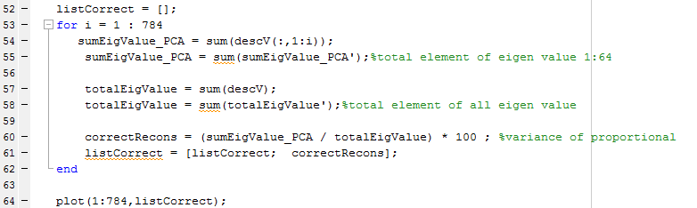

Hasil :

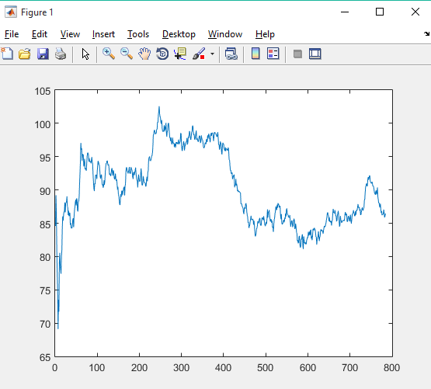

1. ~

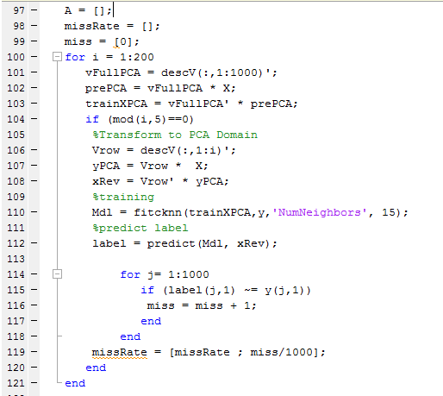

Output :

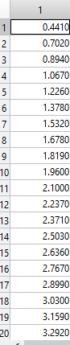

1. ~



Hasil Plot

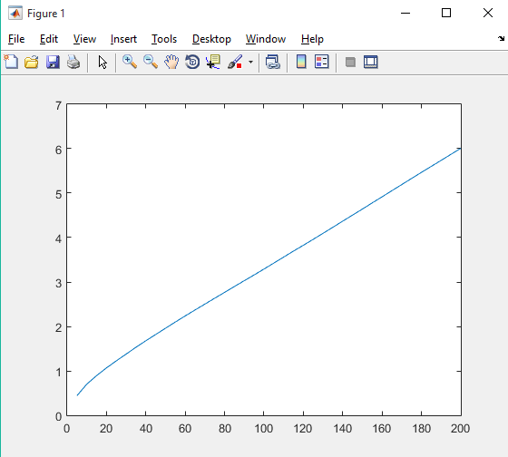

1. 5 first Principal components give best value